Reactive UI

App

# Application details

## Node and angular cli version

D:\>node -v

v8.11.1

## Snapshot of the technology used –

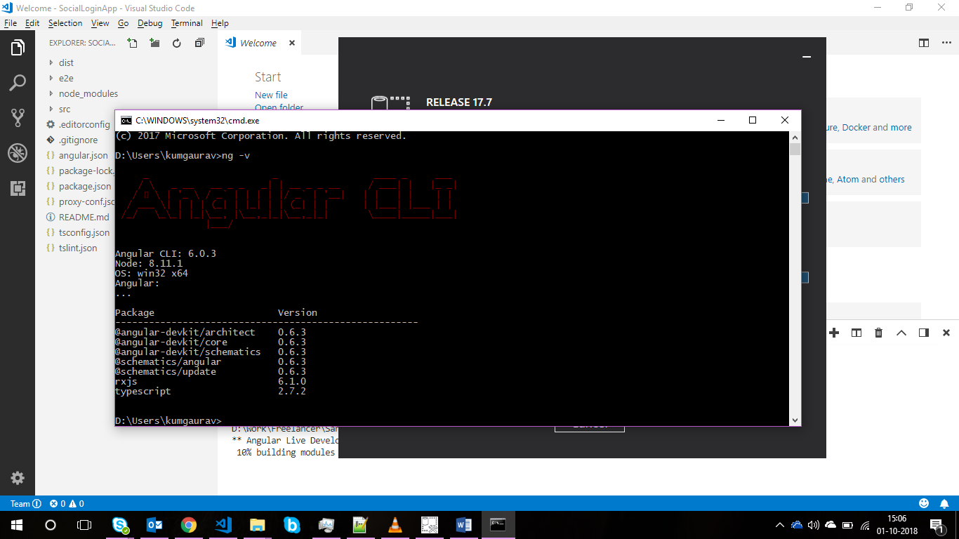

## Command to run first time to build app

**npm install**

## Command to run app in “https” mode

https mode is mandatory to integrate web application with FB else FB login will not work

**ng serve –port=5000 --ssl=true**

**Please note double dash while passing parameters in above command**

# User Flow

## Signup Page Snapshot

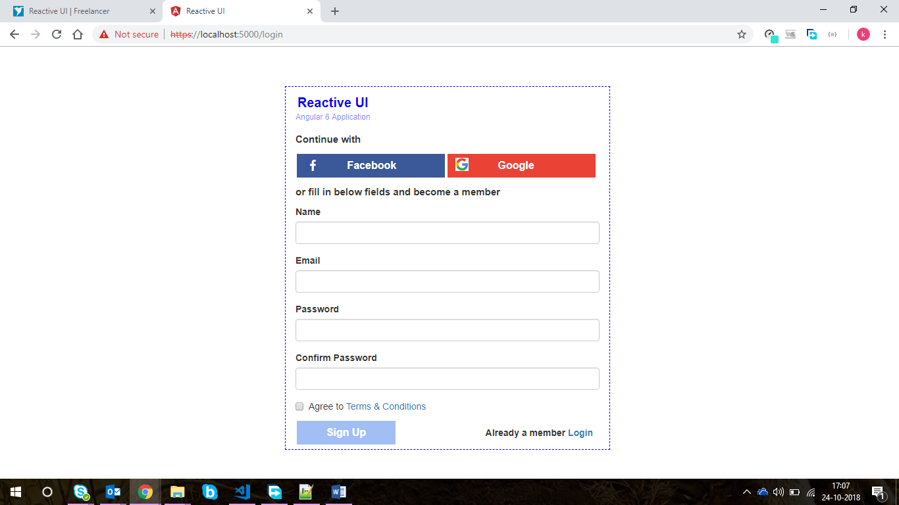

## Login Page Snapshot

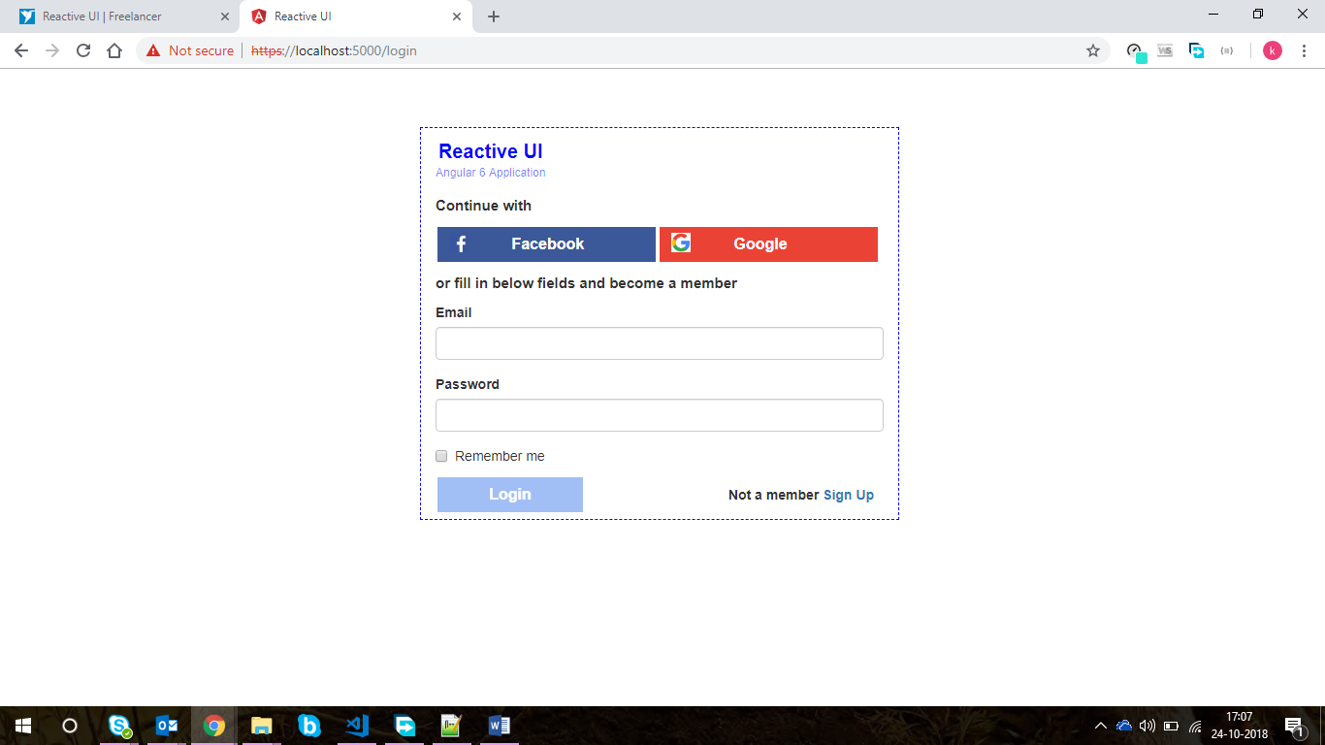

## Flow

1. For Now
   1. signup and login via DB/API is not working
   2. If user continues via Facebook, default landing role page is Vice President (temporary)

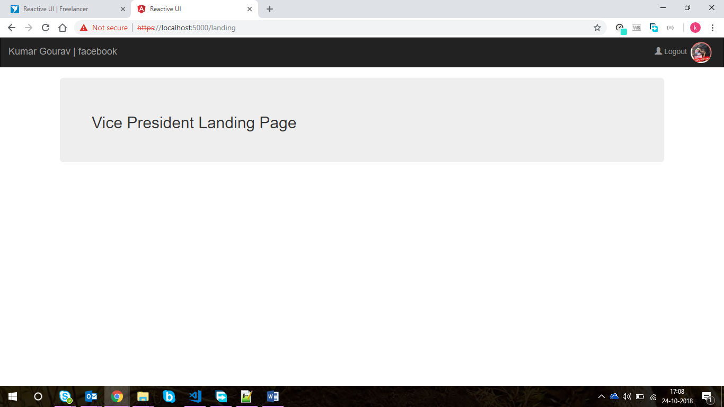

* 1. If user continues via Google, default landing role page is Vice president (temporary)

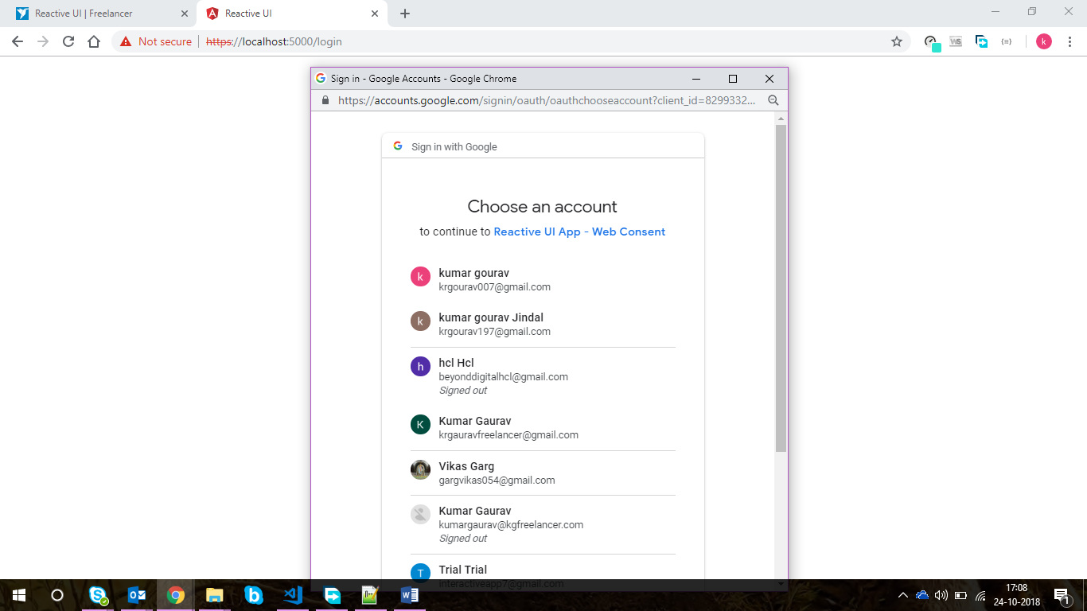

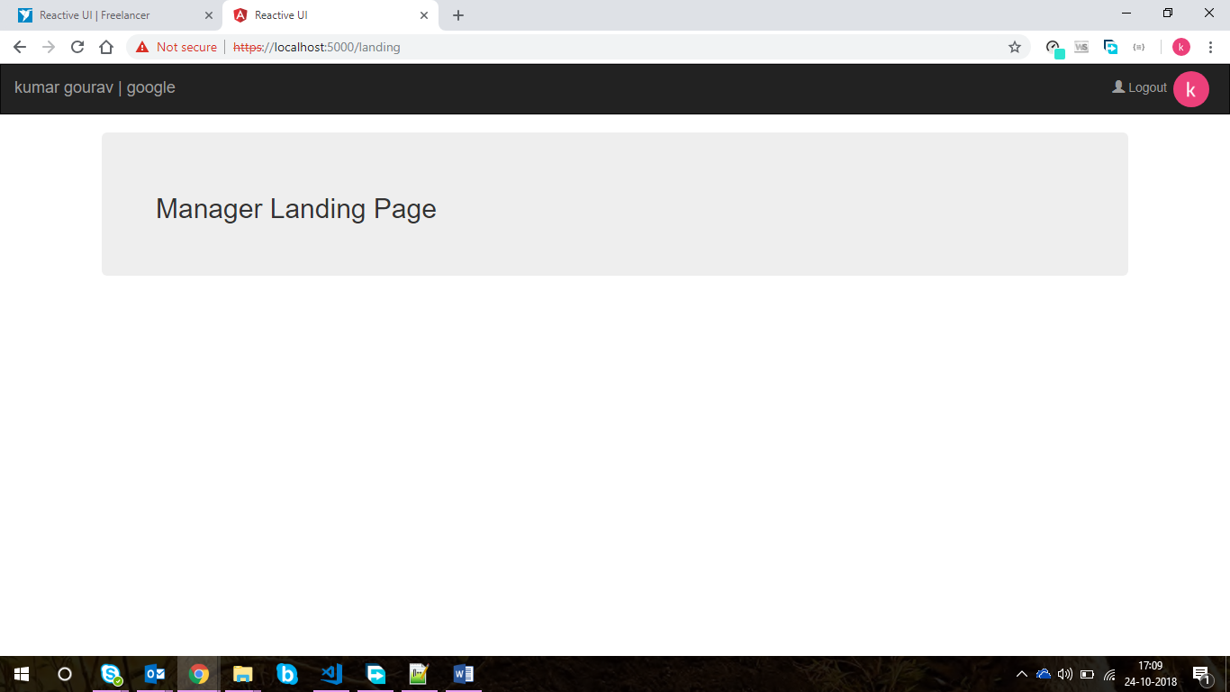

* 1. For now, I am showing using which instance user has logged in in header.
  2. User can logout using the link in navigation menu in header. User will be navigated back to login page.
  3. Corresponding user image will be displayed in header bar.



* 1. Created on not-found error page in case user tries to go a path that does not exist

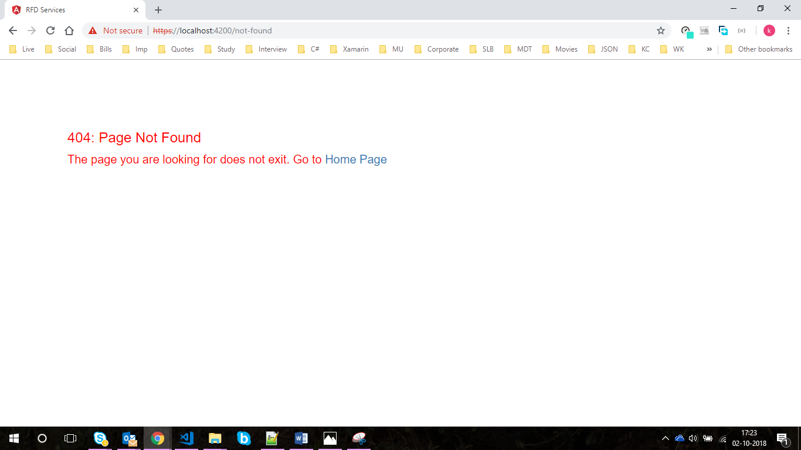

* 1. I have created 3 separate components within angular application as separation of concern. FYI

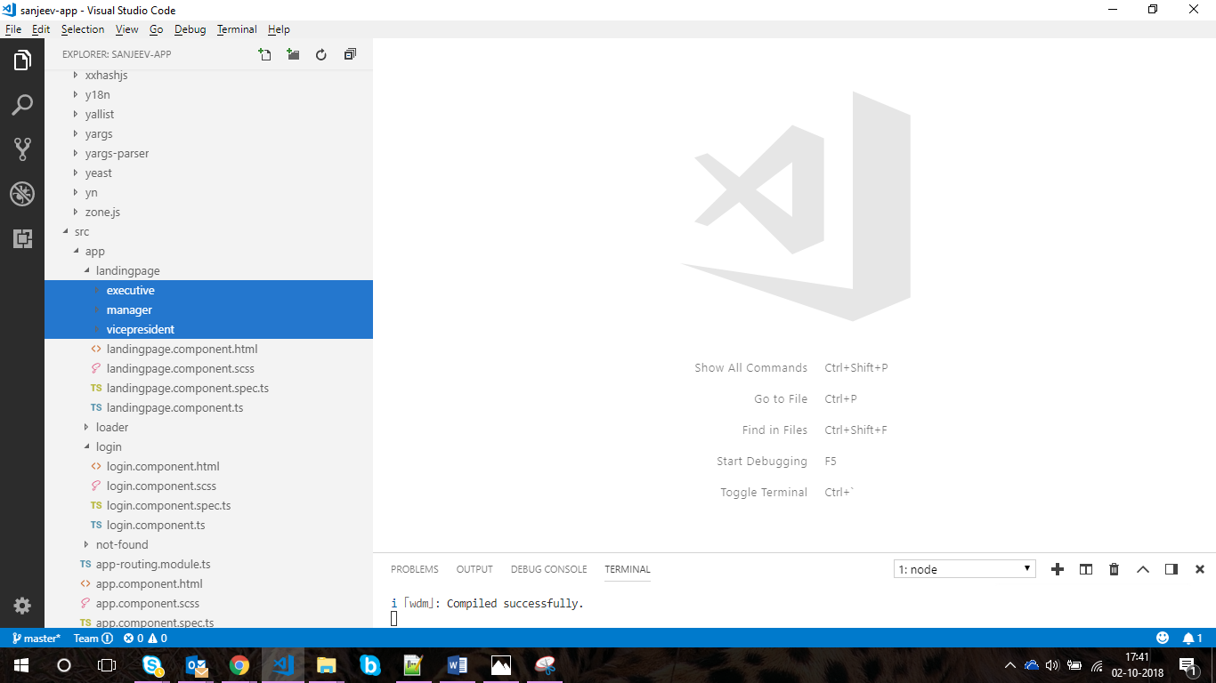

## Client Id

Client id is required to integrate web application for social media. In layman’s term, first we need to register our web application on social site (FB, google and linked in) and then they provide us a client id which we integrate in out angular app > app.module.ts page

**Note: For now, I have created the client id but since it is your app, so it is recommended that you must register this app with social site and create client Id.**

### FB Client Id Snapshot

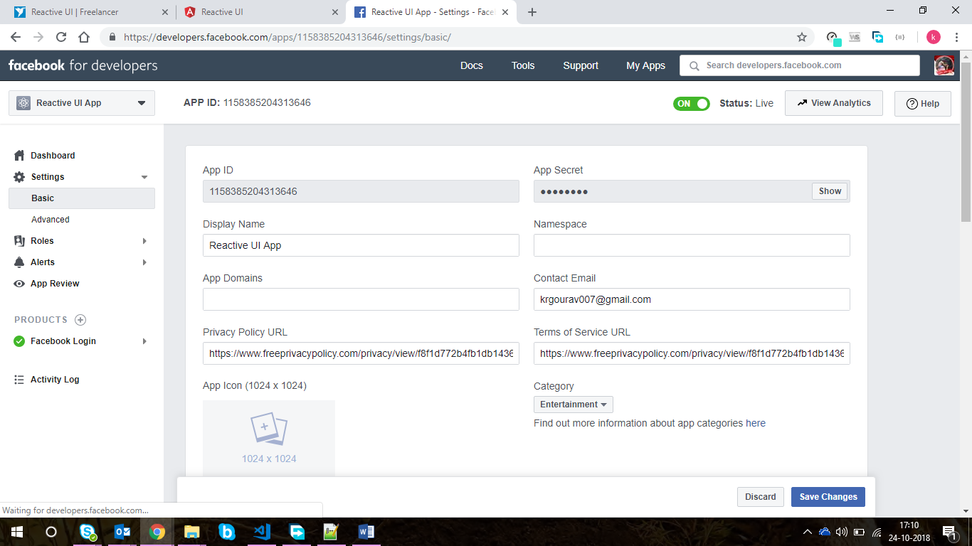

### Google Client Id Snapshot

